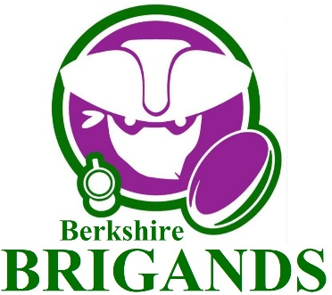

Rugby in Berkshire soon available to even more people than ever.

What is mixed ability rugby?
It is regular full contact rugby… for rugby’s sake. If you happen to have some form of disability or barrier but want to play regular rugby, then you are more than welcome. The same goes if you have no disability or barrier. It is not a disability team. Players are not classified by physical, intellectual or mental abilities and the game is played using all the usual laws of rugby.

How did Berkshire Brigands come about?
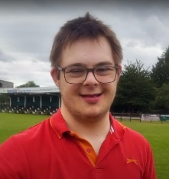
The inspiration for Berkshire Brigands comes from Duncan Stonehouse who has Down Syndrome. Duncan’s brother Drew has played rugby from an early age at Reading RFC, and Duncan simply wants to play contact rugby alongside his brother. See Duncan explain in his own words at https://youtu.be/ruqXiLlJRVA

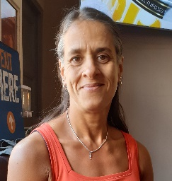
Reading RFC President Yasmin Miller comments,” People always tell me Reading is a friendly and welcoming club, and that’s really important to me. It’s fantastic to extend our welcome to a new sector of society and give even more people the chance to enjoy rugby. I can’t wait to see Duncan on the pitch with Drew for the first time.”

When and where will it happen?
Berkshire Brigands Mixed Ability Rugby team will start regular sessions on Thursdays (6.30 - 8pm) and Saturdays (11am - 12.30pm) at Reading RFC starting on Saturday 26th September and is open to anyone aged 18 or over to join in. See also https://www.facebook.com/BrigandsRugby/videos/659372728312132

Background
Berkshire Brigands Mixed Ability Rugby team has been set up with the support of Berkshire RFU, Reading RFC, CH Rugby, Get Berkshire Active and IMAS - International Mixed Ability Sports, who have helped us connect with established Mixed Ability Rugby teams across the UK. The team will adhere to all RFU, Government and Berkshire RFU policies and guidelines, like any other team. They will play to normal adult rugby laws, with the only exception being uncontested scrums.

For further details please email brigandsrugby@gmail.com

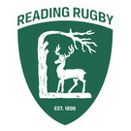
Reading RFC, Holme Park, Sonning Lane, Reading, Berkshire, RG4,6ST
0118 969 6592

