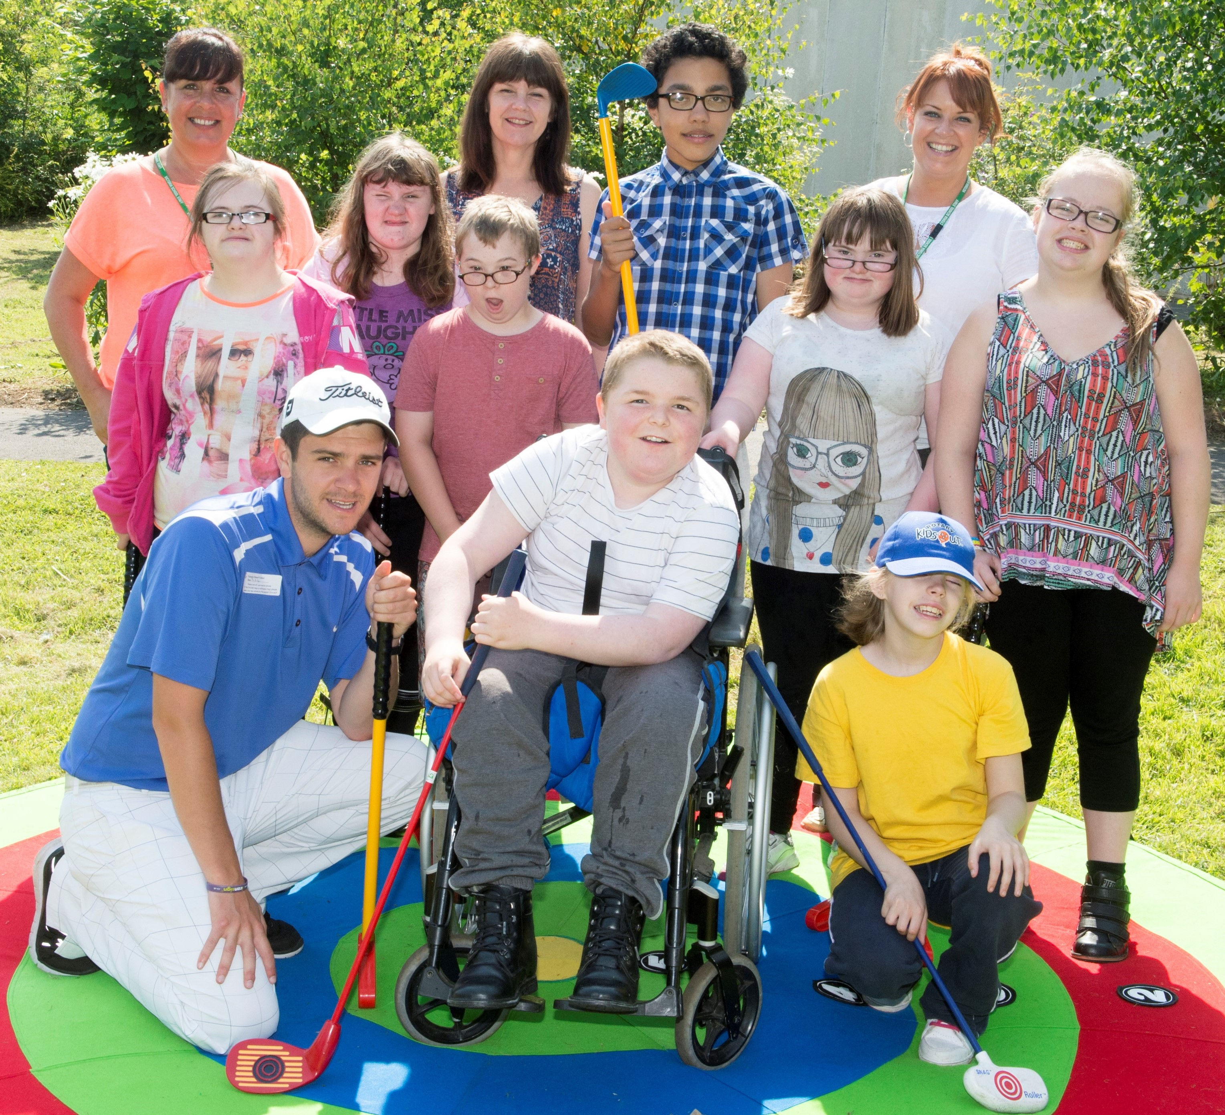

BB&O Feel Inspired

**Golf Academy**

# *Changing the lives of young people with special educational needs through golf*

The Feel Inspired Golf Academy is an initiative designed to bring golf to children and young people with special educational needs, intellectual or physical difficulties. The emphasis is on golf as a lifetime sport for **everyone** with participation, enjoyment and achievement more important than ‘winning’.

“My son has been made to feel very welcome and enjoys the teaching which is relaxed and fun. His participation has contributed not only to his golf but also to his social interaction and confidence.”

Coaching takes place in a fun, friendly and inclusive environment and the focus is on developing each participant’s individual golf skills whilst simultaneously promoting and practicing life skills such as co-operation, honesty, sportsmanship and, of course, perseverance, in a relaxed, supportive environment. There is a strong emphasis on positive reinforcement coaching strategies and an award system for all participants to promote enjoyment and positive engagement.

The affordable sessions are held weekly .

“My child loves attending and always looks forward to it. The coaches make sure that each child feels safe, happy and included.”

[Click here](https://youtu.be/4RqHUVx_H6o) to see a video from one of the centres.

Contact Us: Alan Leason (Programme Manager)

e-mail: [**alan.leason@btopenworld.com**](mailto:alan.leason@btopenworld.com)

phone: 07774 805644(M) 01189 698730(H)

Photograph copyright ©Leaderboard Photography

BB&O Feel Inspired

**Golf Academy**

# *Changing the lives of young people with special educational needs through golf*

The Feel Inspired Golf Academy is an initiative designed to bring golf to children and young people with special educational needs, intellectual or physical difficulties. The emphasis is on golf as a lifetime sport for **everyone** with participation, enjoyment and achievement more important than ‘winning’.

“My son has been made to feel very welcome and enjoys the teaching which is relaxed and fun. His participation has contributed not only to his golf but also to his social interaction and confidence.”

Coaching takes place in a fun, friendly and inclusive environment and the focus is on developing each participant’s individual golf skills whilst simultaneously promoting and practicing life skills such as co-operation, honesty, sportsmanship and, of course, perseverance, in a relaxed, supportive environment. There is a strong emphasis on positive reinforcement coaching strategies and an award system for all participants to promote enjoyment and positive engagement.

The affordable sessions are held weekly (£25 for 6 sessions).

“My child loves attending and always looks forward to it. The coaches make sure that each child feels safe, happy and included.”

[Click here](https://youtu.be/4RqHUVx_H6o) to see a video from one of the centres.

Contact Us: Alan Leason (Programme Manager)

e-mail: [**alan.leason@btopenworld.com**](mailto:alan.leason@btopenworld.com)

phone: 07774 805644(M) 01189 698730(H)

Photograph copyright ©Leaderboard Photography

|  |
| --- |
| The Feel Inspired Golf Academy was set up in 2011 to allow young people with Special Educational Needs and Disabilities to learn and enjoy the game of golf.  Supported by the BB&O County Golf Organization , England Golf and The Golf Foundation, partner clubs in Berks, Bucks and Oxon offer the Academy coaching for youngsters aged 8 to 21.  After attending a ‘taster’ session, either at a host club or school, young people are invited to join the Golf Academy at their nearest participating Golf Club. |

