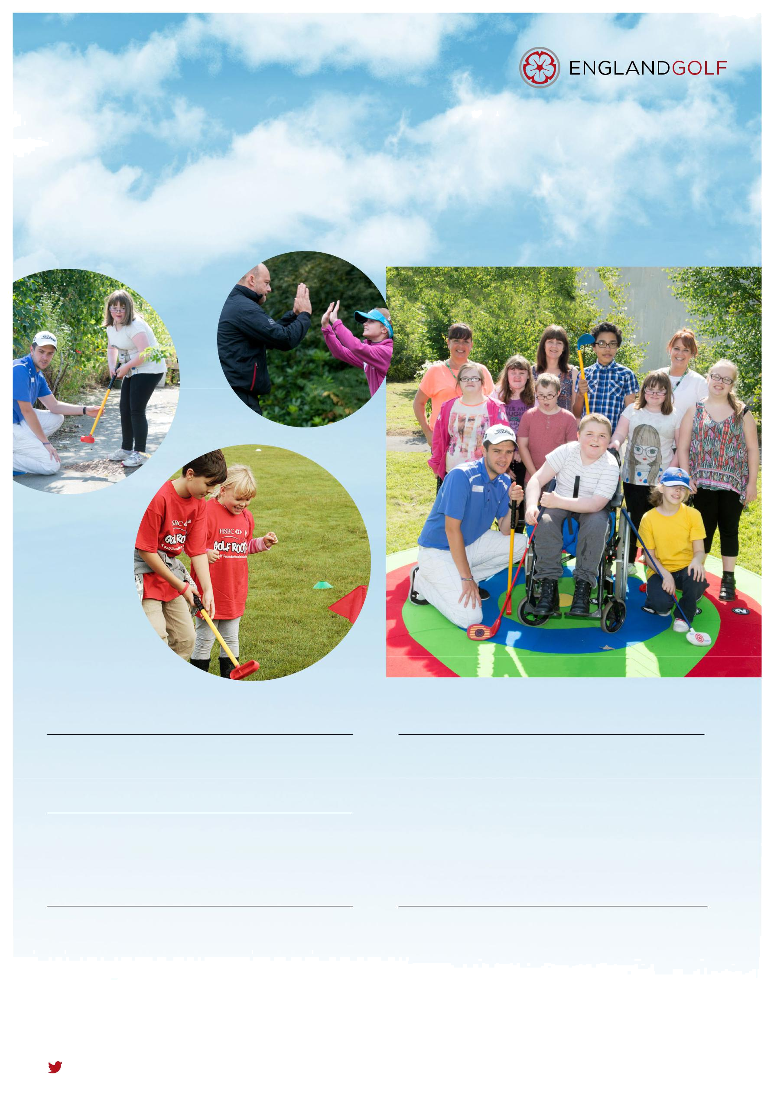



For SEND Children aged 8-21 to get into golf
Feel Inspired Golf Academy

Program’s Aim/Mission : is to change such children’s lives through Golf

Price –
£8 per session. (+ Academy registration fee of £15 due yearly)

When - Most Saturdays 12 noon – 1pm
Sessions include: Fun and practical lessons providing the skills req’d to play golf

Where – Sand Martins Golf Club Finchampstead Road Wokingham Berkshire
RG40 3RQ

Contact Us- via Program Manager – Alan Leason
e-mail alan.leason@btopenworld.com Photographs copyright © Leaderboard Photography.
phone 07774805644(M) 01189698730(H)
@englandgolf @golfrootshq #inclusivegolf facebook.com/englandgolf

